Objectives:

* Task 1: Create and assign tags via the Azure portal
* Task 2: Enforce tagging via an Azure policy
* Task 3: Apply tagging via an Azure policy

Architecture diagram:

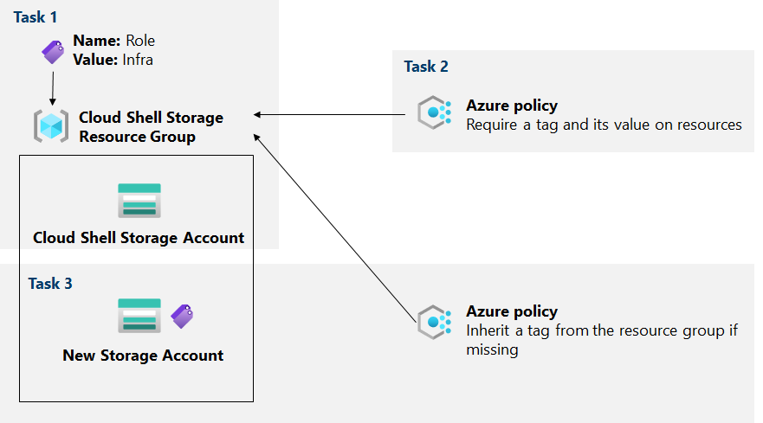

Task 1: Create and assign tags via the Azure portal.

In this task, we will create and assign a tag to an Azure resource group via the Azure portal:

Here, we check our storage account with the PowerShell command described, navigate to it and create a new tag:

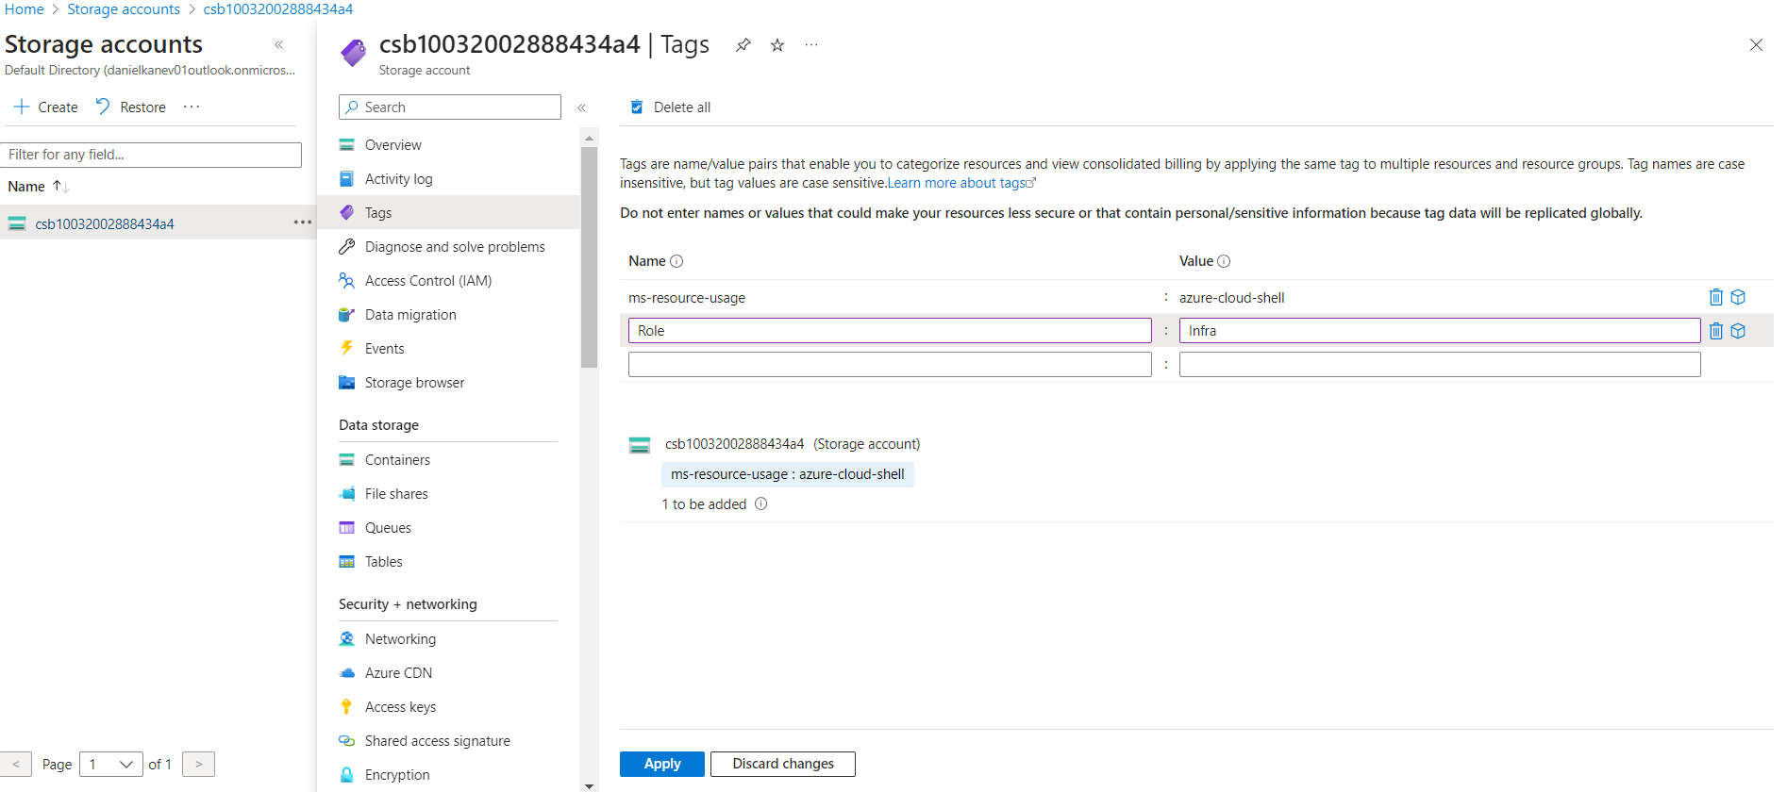

Task 2: Enforce tagging via an Azure policy.

In this task, we will assign the built-in Require a tag and its value on resources policy to the resource group and evaluate the outcome:

First, we have to assign the correct tag policy as described, modify it’s settings and create a new storage account with this enforced tag named Role, with value Infra.

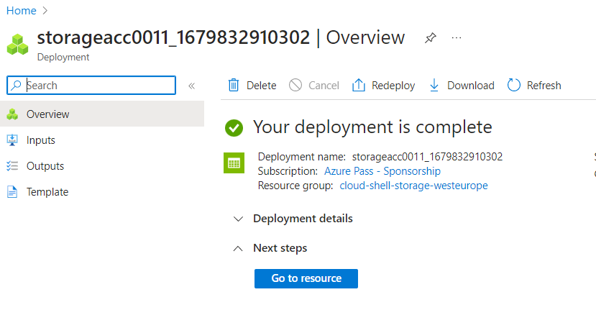

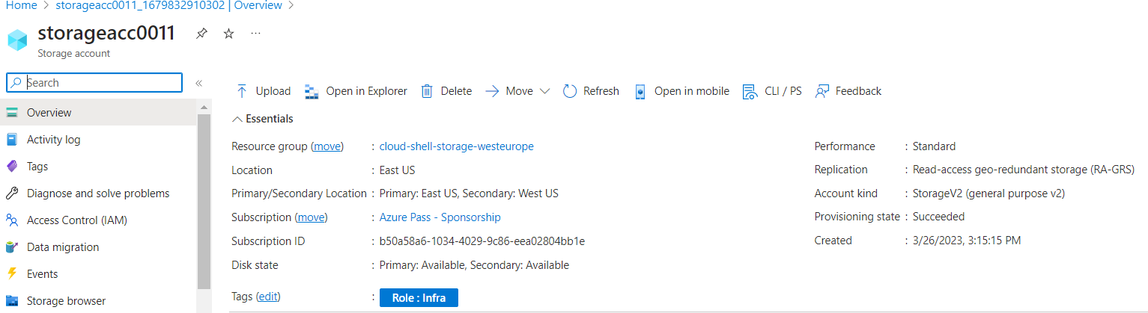

Task 3: Apply tagging via an Azure policy.

In this task, we will use a different policy definition to remediate any non-compliant resources:

Here, we modify some policy assignments and definitions as described, go back to the initial resource group that is hosting the storage account used in the from the Cloud Shell home drive, and create a new storage account in it. We verify that the validation has passed:

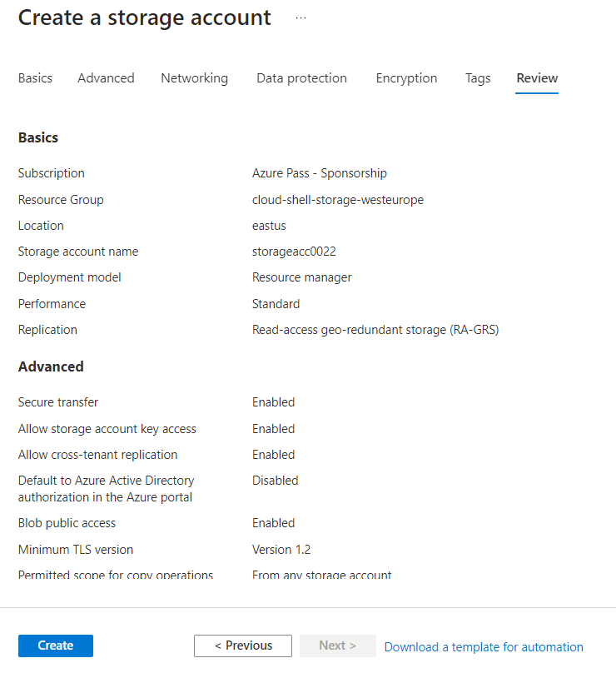

And the we can see that the tag Role with value Infra have been automatically assigned to the resource:

